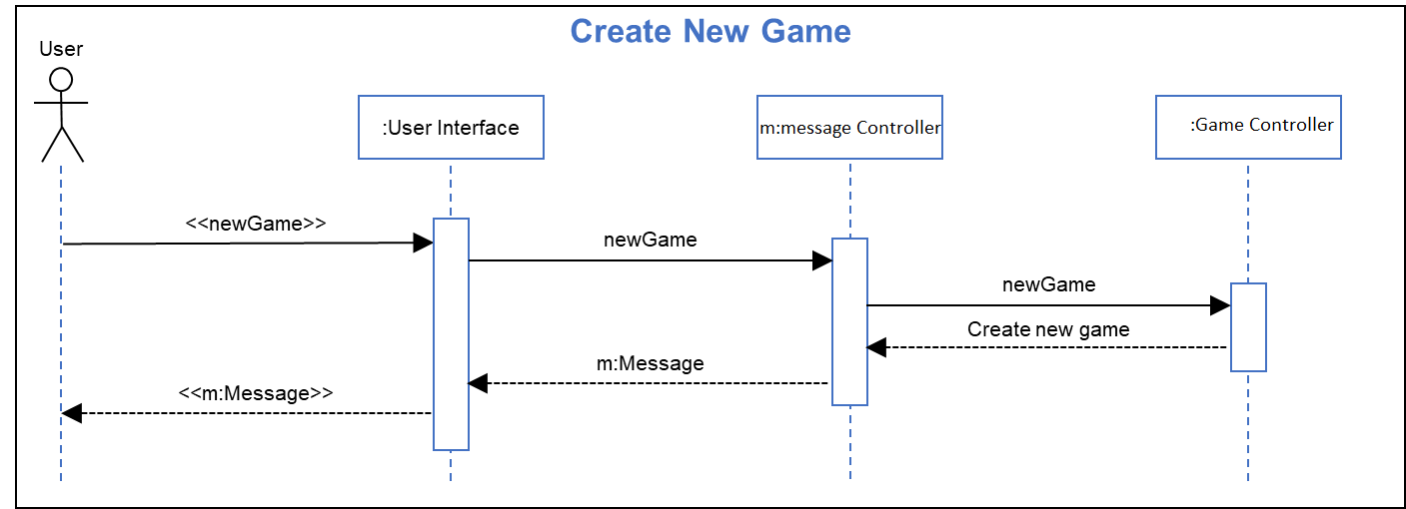
Analysis Sequence Diagram:

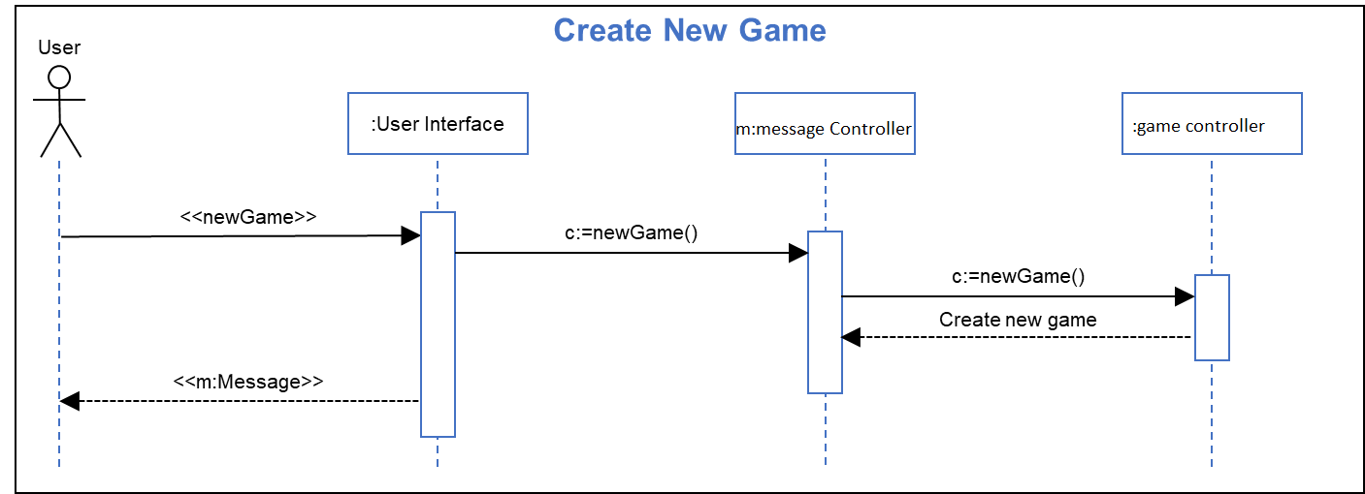
Design Sequence Diagram:

Sequence Step Description:
Title: Create new game
Actor(s): User
Precondition: User has selected “yes” at prompt to create new game
Outcome: A new game is started at the start of level one.
User Actions | System Actions
3. User clicks UI “yes” button
 | 4.1. Game UI generates a new game message and sends it to the message controller.
 | 4.2 Message controller sends the new game call to the game controller.
 | 4.3 The game controller initializes a new game.
 | 5/6 The user interface displays the game view

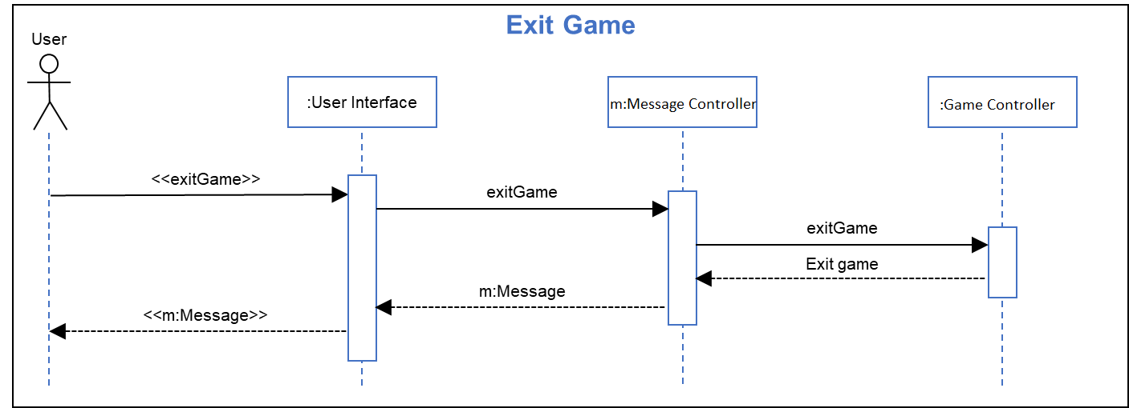
Analysis Sequence Diagram:

Design Sequence Diagram:
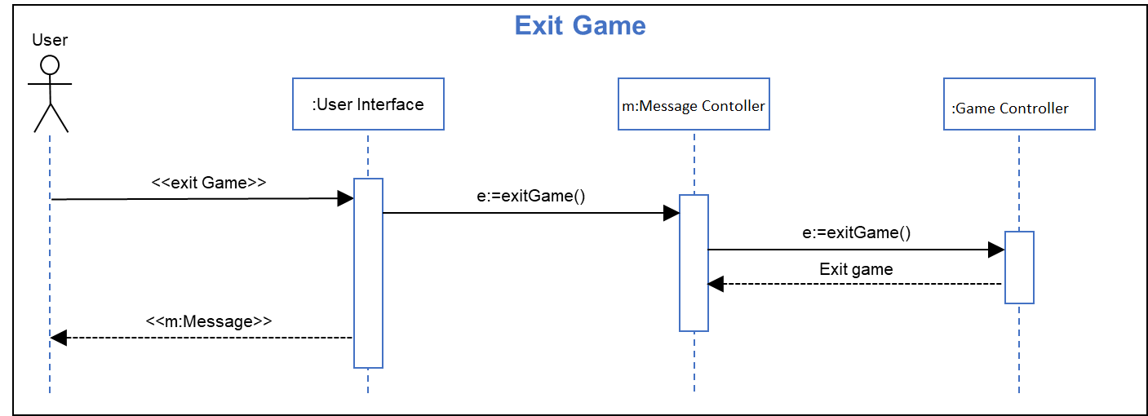

Sequence Step Description:
Title: Exit game
Actor(s): User
Precondition: User has selected “yes” at prompt to exit game
Outcome: The current game session is ended and the title screen is shown
User Actions | System Actions
3. User clicks UI “yes” button
 | 4.1. Game UI generates an exit game message and sends it to the message controller.
 | 4.2 Message controller sends the exit game call to the game controller.
 | 4.3 The game controller ends the current game.
 | 5. The user interface displays the initial title screen.

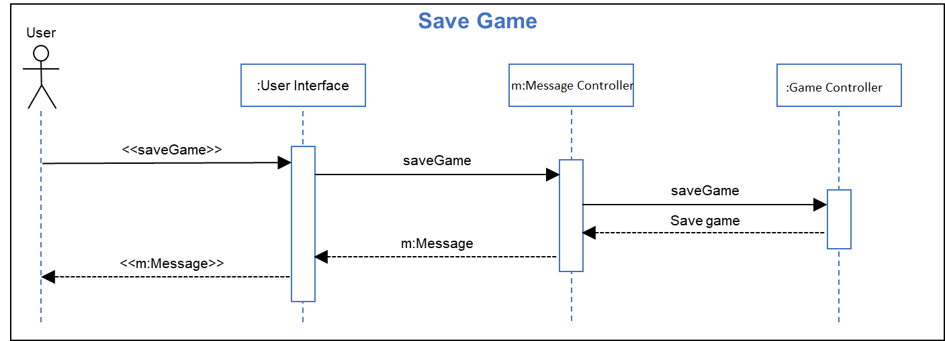
Analysis Sequence Diagram:

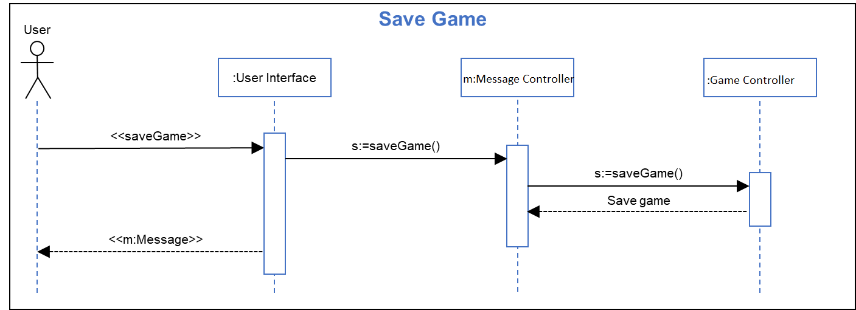
Design Sequence Diagram:

Sequence Step Description:
Title: Save game
Actor(s): User
Precondition: User has selected “yes” at prompt to save game
Outcome: The current game session state is saved and the game session is resumed.
User Actions | System Actions
3. User clicks UI “yes” button
 | 4.1. Game UI generates a save game message and sends it to the message controller.
 | 4.2 Message controller sends the save game call to the game controller.
 | 4.3 The game controller saves the current game state.
 | 5. The user interface returns to the game view.

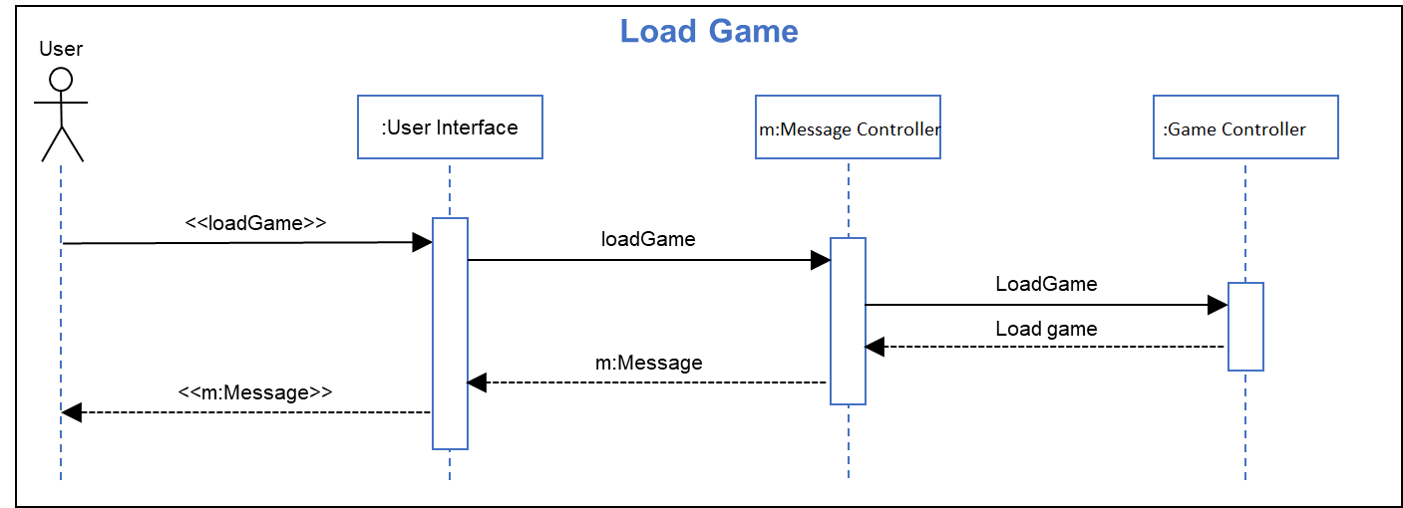
Analysis Sequence Diagram:

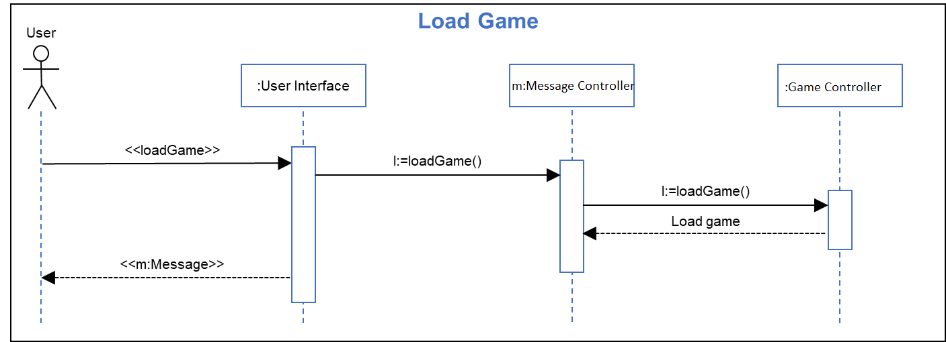
Design Sequence Diagram:

Sequence Step Description:
Title: Load game
Actor(s): User
Precondition: User has selected “yes” at prompt to load game
Outcome: The current game session state is saved and the game session is resumed.
User Actions | System Actions
3. User clicks UI “yes” button
 | 4.1. Game UI generates a load game message and sends it to the message controller.
 | 4.2 Message controller sends the load game call to the game controller.
 | 4.3 The game controller loads the game data saved previously.
 | 5/6. The user interface returns to the game view.

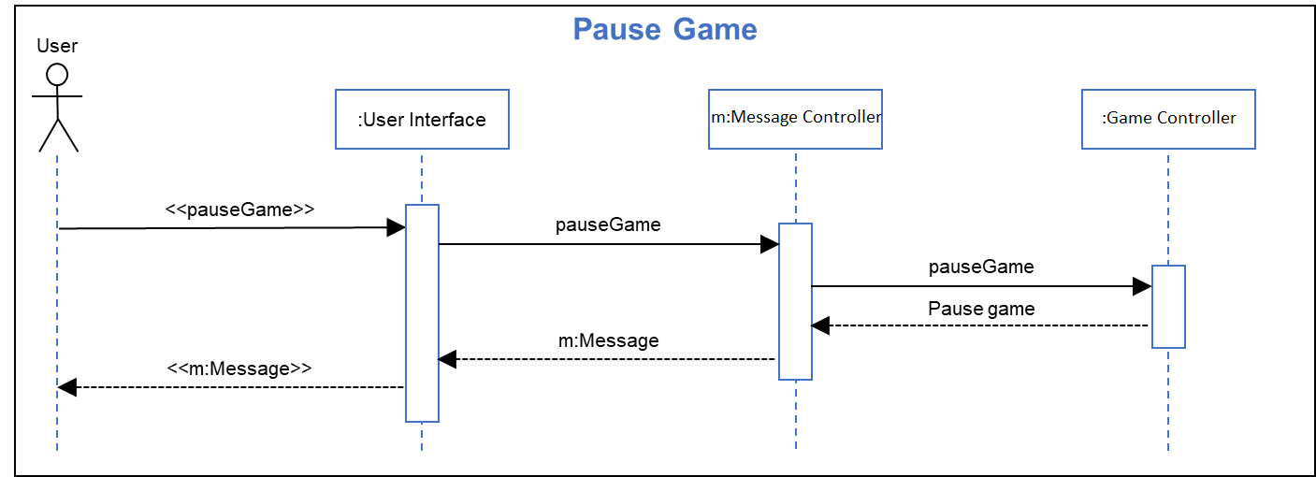
Analysis Sequence Diagram:

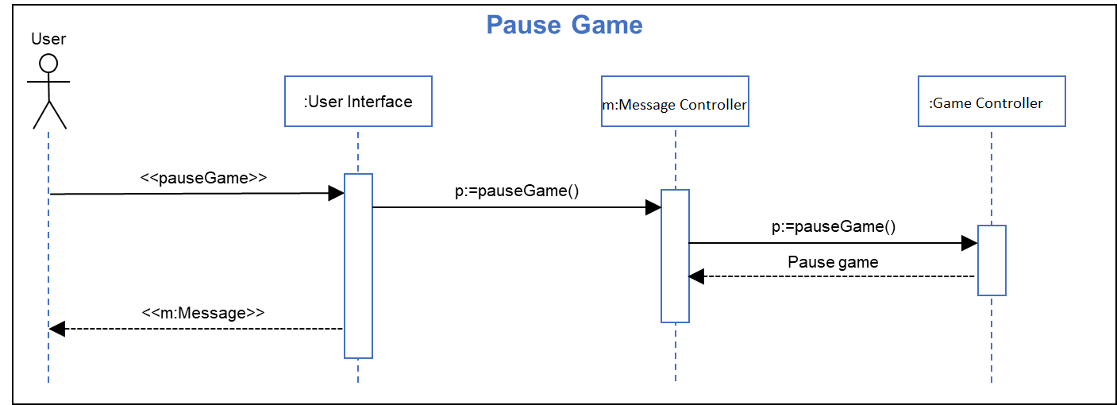
Design Sequence Diagram:

Sequence Step Description:
Title: Pause Game
Actor(s): User
Precondition: User is playing the game.
Outcome: Game is paused, user is notified that the game is paused.
User Actions | System Actions
1. User clicks UI pause button
 | 2.1. Game UI generates a pause game message and sends it to the message controller.
 | 2.2 Message controller sends the pause game call to the system controller.
 | 2.3 The system controller pauses the game.
 | 2.4 The user interface displays that the game is paused.

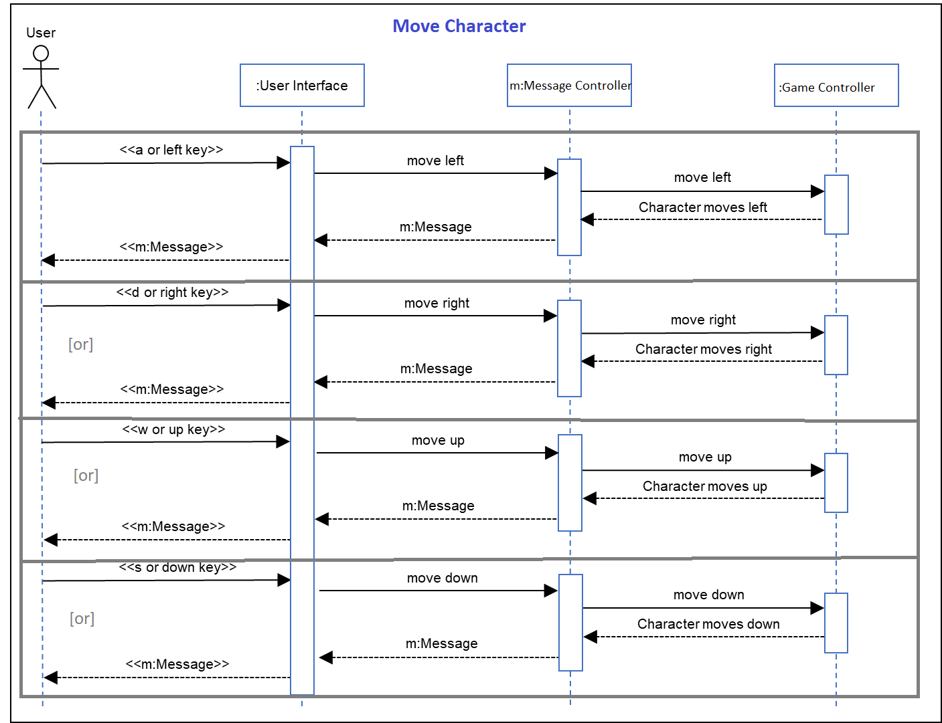
Analysis Sequence Diagram:

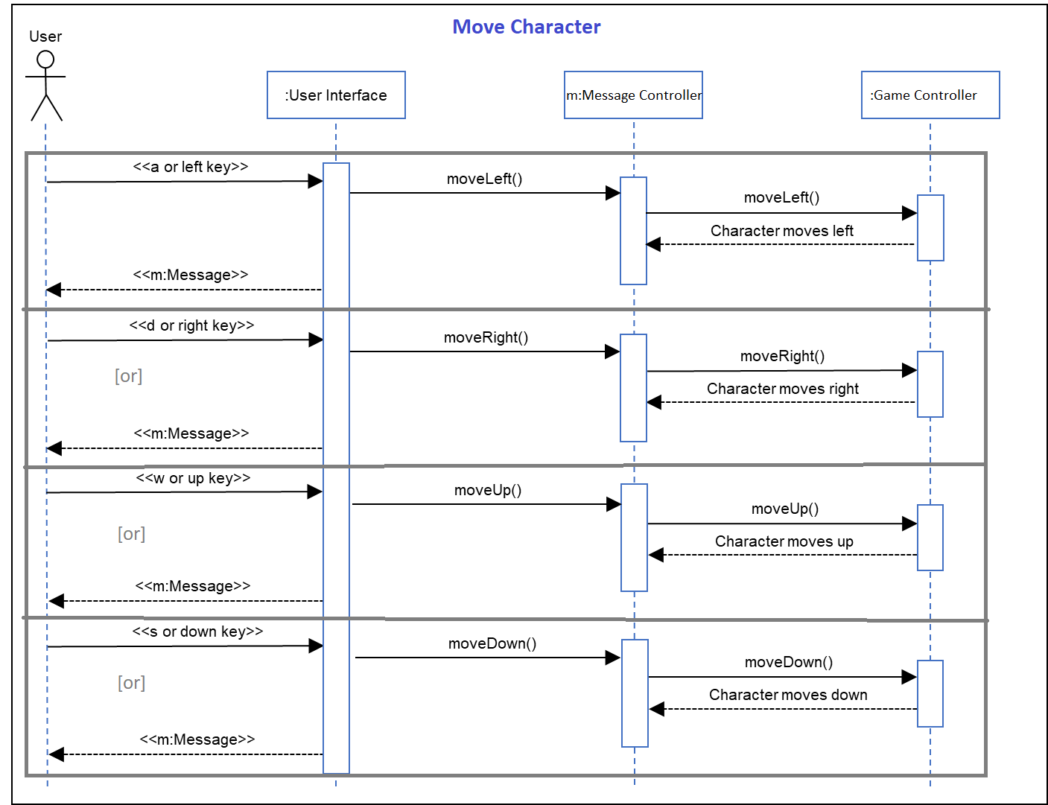
Design Sequence Diagram:

Sequence Step Description:
Title: Move Character
Actor(s): User
Precondition: User is in an active play-session, game is not paused.
Outcome: The character moves in the direction desired by the player.
User Actions | System Actions
1. User presses movement key
2.1. If player enters
(a) a-key, or
(b) left arrow key
 | 2.1.1. The UI sends a message to the message controller.
 | 2.1.2. Message controller sends a call to the game controller for the to character move left.
 | 2.1.3. The game controller moves the player left.
2.2. If player enters
(a) d-key, or
(b) right arrow key
 | 2.2.1. The UI sends a message to the message controller.
 | 2.2.2. Message controller sends a call to the game controller for the to character move right.
 | 2.2.3. The game controller moves the player right.
2.3. If player enters
(a) w-key, or
(b) up arrow key
 | 2.3.1. The UI sends a message to the message controller.
 | 2.3.2. Message controller sends a call to the game controller for the to character move up.
 | 2.3.3. The game controller moves the player up. (jump)
2.4. If player enters
(a) s-key, or
(b) down arrow key
 | 2.4.1. The UI sends a message to the message controller.
 | 2.4.2. Message controller sends a call to the game controller for the to character move down.
 | 2.4.3. The game controller moves the player down. (crouch)

